# INSTITUTE OF ENGINEERING

ADVANCED COLLEGE OF ENGINEERING AND MANAGEMENT

Kupondole, Lalitpur

**(AFFILIATED TO TRIBHUVAN UNIVERSITY)**



Lab no:7

Subject: Computer Network

**Submitted By: Submitted To:**

Department of Computer

and

Electronics Engineering

Name: Sameep Dhakal

Roll no: ACE074BCT063

Date: 09/07/2021

# Lab 7

# Title: Internet Protocol Address Version 6

# Objective:

* To learn about configuration of internet protocol version 6

# Theory:

Internet Protocol version 6 (IPv6) is the most recent version of the [Internet Protocol](https://en.wikipedia.org/wiki/Internet_Protocol) (IP), the [communications protocol](https://en.wikipedia.org/wiki/Communication_protocol) that provides an identification and location system for computers on networks and routes traffic across the [Internet](https://en.wikipedia.org/wiki/Internet). The main advantage of IPv6 over IPv4 is its larger address space.

The size of an IPv6 address is 128 bits, compared to 32 bits in IPv4. IPv6 specifies a new [packet format](https://en.wikipedia.org/wiki/IPv6_packet), designed to minimize packet header processing by routers. Because the headers of IPv4 packets and IPv6 packets are significantly different, the two protocols are not interoperable. However, most transport and application-layer protocols need little or no change to operate over IPv6; exceptions are application protocols that embed Internet-layer addresses, such as [File Transfer Protocol](https://en.wikipedia.org/wiki/File_Transfer_Protocol) (FTP) and [Network Time Protocol](https://en.wikipedia.org/wiki/Network_Time_Protocol) (NTP), where the new address format may cause conflicts with existing protocol syntax.

# Design:

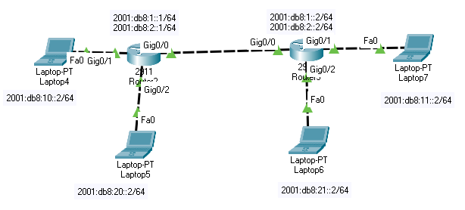

# Procedure:

1. First the required tools are selected.
2. The required ports of the routers were turned on.
3. Then Ip and subnet mask of the routers and laptops were set
   1. For each laptop this was done by going to the desktop and Ip configurations on Ipv6
   2. For routers this was done by going to the configuration and selecting the required port
4. Required connections were made between the routers and laptops.
5. VLAN were set in the router for the secure connection.
6. Then Static routing is done for the connection of the devices in different network.

# Code:

**Router 1**

Router>enable

Router#vlan database

Router(vlan)#vlan 10 name exam

Router(vlan)#vlan 20 name account

Router(vlan)#exit

Router#config terminal

Router(config)#ipv6 unicast-routing

Router(config)#interface gig0/0

Router(config-if)#no ip address

Router(config-if)#no shutdown

Router(config-if)#exit

Router(config)#interface gig0/0.10

Router(config-subif) # ipv6 address 2001:db8:1::1/64

Router(config-subif)#encapsulation dot1q 10

Router(config-subif)#ipv6 enable

Router(config-subif)#no shutdown

Router(config-subif)#exit

Router(config)#interface gig0/0.20

Router(config-subif)#ipv6 address 2001:db8:2::1/64

Router(config-subif)#encapsulation dot1q 20

Router(config-subif)#no shutdown

Router(config-subif)#exit

Router(config)#interface gig0/1

Router(config-if)#ipv6 address 2001:db8:10::1/64

Router(config-if)#no shutdown

Router(config-if)#interface gig0/2

Router(config-if)#ipv6 address 2001:db8:20::1/64

Router(config-if)#no shutdown

Router(config-if)#exit

Router(config)#ipv6 route 2001:db8:11::/64 2001:db8:1::2

Router(config)#ipv6 route 2001:db8:11::/64 2001:db8:2::2

Router(config)#ipv6 route 2001:db8:21::/64 2001:db8:2::2

Router(config)#ipv6 route 2001:db8:21::/64 2001:db8:1::2

Router(config)#exit

Router# wr

**Router 2**

Router> en

Router#vlan database

Router(vlan)#vlan 10 name exam

Router(vlan)#vlan 20 name account

Router(vlan)#exit

Router#conf t

Router(config)#ipv6 unicast-routing

Router(config)#int gig0/0

Router(config-if)#no ip addr

Router(config-if)#no shut

Router(config-if)#exit

Router(config)#int gig0/0.10

Router(config-subif)#ipv6 addr 2001:db8:1::2/64

Router(config-subif)#encapsulation dot1q 10

Router(config-subif)#no shut

Router(config-subif)#exit

Router(config)#int gig0/0.20

Router(config-subif)#ipv6 addr 2001:db8:2::2/64

Router(config-subif)#encapsulation dot1q 20

Router(config-subif)#no shut

Router(config-subif)#exit

Router(config)#int gig0/1

Router(config-if)#ipv6 addr 2001:db8:11::1/64

Router(config-if)#no shut

Router(config-if)#exit

Router(config)#int gig0/2

Router(config-if)#ipv6 addr 2001:db8:21::1/64

Router(config-if)#no shut

Router(config-if)#exit

Router(config)#ipv6 route 2001:db8:20::/64 2001:db8:2::1

Router(config)#ipv6 route 2001:db8:20::/64 2001:db8:1::1

Router(config)#ipv6 route 2001:db8:10::/64 2001:db8:1::1

Router(config)#ipv6 route 2001:db8:10::/64 2001:db8:2::1

Router(config)#exit

Router#wr

# Output:

Ping from Laptop 4 to Laptop 7

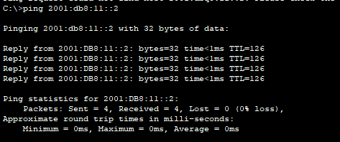

Ping from Laptop 4 to Laptop 6

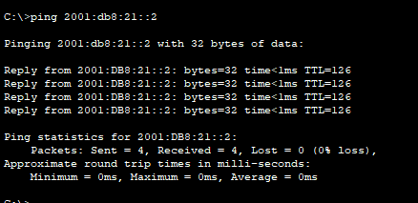

Ping from Laptop 5 to Laptop 6

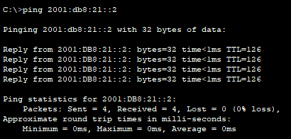

Ping from Laptop 5 to Laptop 7

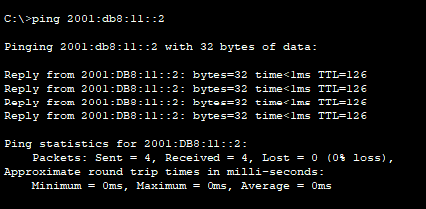

Ping from Laptop 6 to Laptop 4

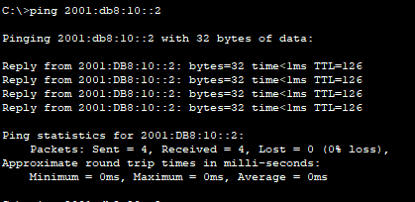

Ping from Laptop 6 to Laptop 4

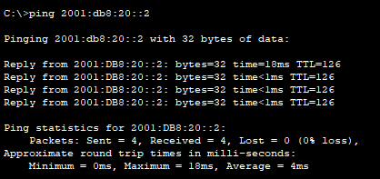

Ping from Laptop 7 to Laptop 4

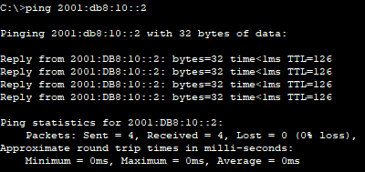

Ping from Laptop 7 to Laptop 4

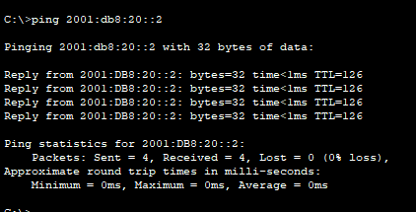

# Result and Conclusion:

In this lab we were able to configure the Ipv6 in the devices and set the VLAN on the router for the secure connection.